Changing Tides and Ingenuity  Marées changeantes et ingéniosité | 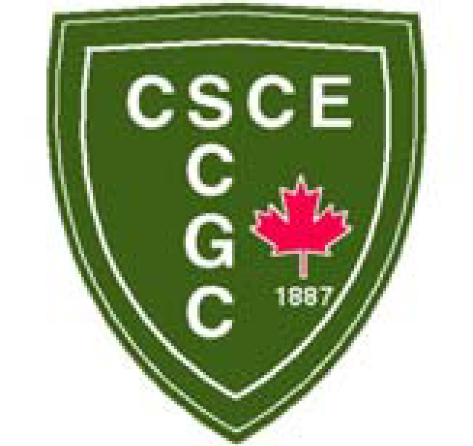
Moncton, Canada
May 24 – 27, 2023 / 24 – 27 mai 2023

TITLE
Author Last Name, First Name^{1,4}, Last Name, First Name² and Last Name, First Name³
¹ Author Affiliation, Country
² Author Affiliation, Country
³ Author Affiliation, Country
⁴ corresponding_author_email@emailaddress.edu
Abstract: Body text of abstract. The abstract should not exceed 350 words.

